Nguyễn Thái Nguyên -056206007730
Từ Ngọc Toàn -060206007621
Trần Thị Đài Trang -075306015984
Trịnh Tuấn Văn -060206007788
Huỳnh Quốc Anh Nhựt -06020600854
Report of group 11
I. General System Description
The student attendance system is built to support lecturers and students in managing, performing, and tracking the attendance process quickly, accurately, and conveniently. The system allows users to log in with personal accounts to access functions appropriate for their specific roles.
II. Functional Requirements
1. General Functions
- Log In: Users (lecturers or students) log in using an account and password to access the system. If the password is forgotten, it can be retrieved via phone number.
- View Personal Information: After logging in, users can view personal details such as full name, phone number, ID number, and role (Lecturer/Student).
2. Functions for Lecturers
- View Classes: Lecturers can view and manage the classes they are in charge of.
- Create Attendance: Lecturers can create attendance sessions for students.
- Edit Attendance: Lecturers can edit created attendance sessions, including the time and add password.
3. Functions for Students
- View Course List: Students can view the list of courses for which they have registered.
- Take Attendance: Students can mark their attendance for a class session based on the time and enter password by the lecturer.
- View Attendance History: Students are permitted to review their own attendance history for each subject.
III. Non-Functional Requirements
1. Usability
- The interface must use clear, readable fonts and appropriate colors.
- System operations must be simple and easy to understand. Specifically, the student attendance process must not exceed 3 steps.
- The system must display clear error messages when a user enters an incorrect password.
2. Reliability
- The system must operate continuously 24/7.
- System reliability must reach over 99.9%, ensuring minimal interruption.
3. Performance
- System response time must not exceed 3 seconds per request.
- The system must be capable of serving over 10,000 students accessing it simultaneously.
- The system must be able to store and manage information for over 100,000 users.
4. Security
- Users must log in with a personal account.
- Each account is allowed to log in on only one device at a time.
- Students are only allowed to view their own attendance history and cannot access data belonging to other students.
5. Design and Technology
- The system is built using the C++ programming language.
- Data is stored in the form of text files (*.txt).

IV. DFD diagram
Level-0
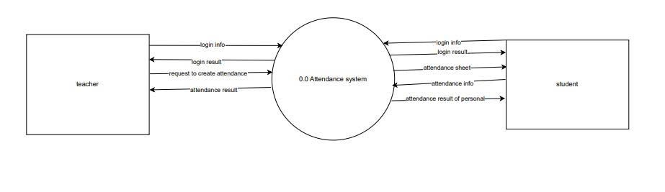

Level-1
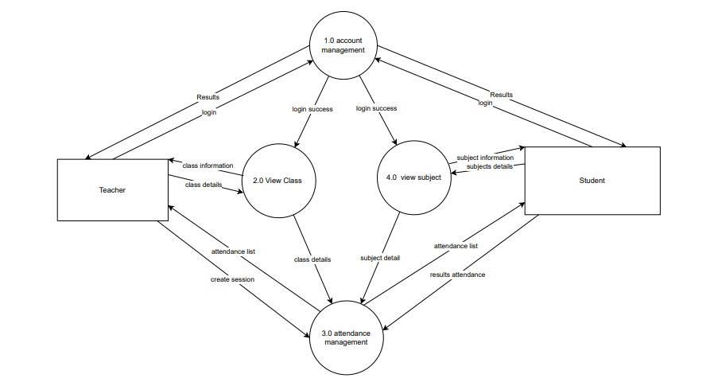

V. Use case diagram
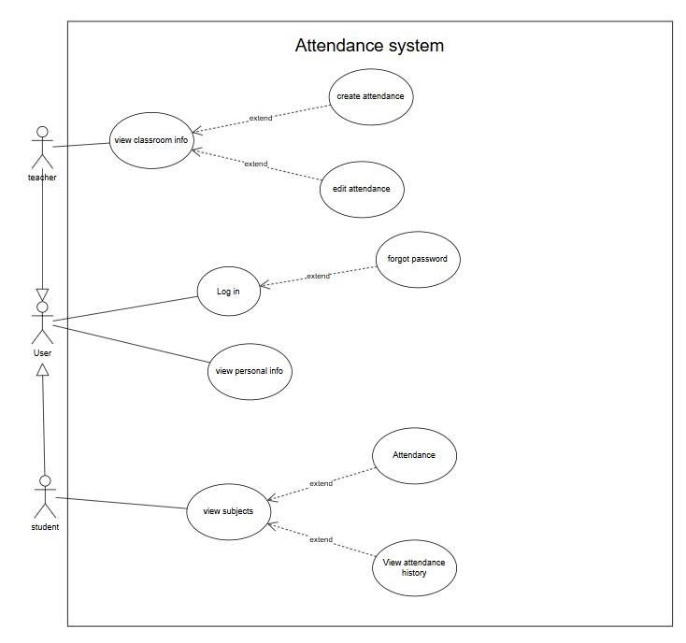
1. list of actor
STT | Actor | Meaning
1 | User | Login, view pesonal infomation
2 | Teacher | Create Attendance, Edit Attendance, View Classroom Information,
3 | Student | View Course Information, Take Attendance, View Attendance History

  - Use-case
STT | Usecase | Meaning | Note
1 | log in | log in
2 | forgot password | Reset password
3 | View personal information | View information: full name, phone number, email,....
4 | View Classroom Information | View class information: room,subjects.
5 | Create Attendance | Create Attendance
6 | Edit Attendance | Edit attendance
7 | View Course Information | View Course Name, Semester,Lecturer
8 | Take Attendance | Take Attendance
9 | View Attendance History | View list of attendance

2. Use Case: Log In

2.1 Summary
This Use Case allows lecturers and students to access the attendance system using their provided accounts.

2.2 Flow of Events
2.2.1 Basic Flow
- The system displays the login form requiring a username and password.
- The user enters their login credentials and clicks the "Log In" button.
- The system validates the data and authenticates the user information.
- The system determines the user role:
  - Lecturer: Redirects to the Class List page.
  - Student: Redirects to the Course page.
2.2.2 Alternative Flows
- Invalid Credentials: If the username or password is incorrect, the system reports an error and requests re-entry.

2.3 Special Requirements
None.

2.4 Pre-conditions
The user is not logged in.

2.5 Post-conditions
The user is successfully logged in, and a session is initialized.

2.6 Extension Points
- Use Case "Forgot Password": If the user clicks the "Forgot Password" link.

3. Use Case: Forgot Password

3.1 Summary
Allows users to recover or reset their password via an OTP (One-Time Password) sent to their phone number.

3.2 Flow of Events
3.2.1 Basic Flow
- The system displays the "Forgot Password" button.
- The user clicks the button to request an authentication OTP via phone number.
- The system checks if the phone number is valid.
- If valid, the system sends an OTP and maintains it for a short duration.
- The user enters the received code and clicks "Confirm."
- The system verifies the accuracy of the code.
- If correct, the system displays the "Reset Password" screen.
- The user enters the new password and confirms it by entering it a second time.
3.2.2 Alternative Flows
- Unregistered Phone: If the phone number is not registered in the system, the system reports "Phone number does not exist."
- Wrong OTP: If the user enters the wrong OTP, the system reports an error and allows re-entry.
- OTP Expired: If the input time exceeds the limit, the old OTP is invalidated. The system displays a "Resend Code" button for the user to request a new one.

3.3 Special Requirements
- The OTP consists of 6 numeric characters and is valid for a short period (approximately 1 to 2 minutes).

3.4 Pre-conditions
The user is at the login screen.

3.5 Post-conditions
- The user's password is changed.
- The user is redirected to the login screen to sign in with the newly created password.

3.6 Extension Points
None.

4. Use Case: View Personal Info

4.1 Summary
Allows users to review their personal information stored in the system.

4.2 Flow of Events
4.2.1 Basic Flow The user views the following information based on their role:
- Student: Displays Student ID, Full Name, Date of Birth, Gender, Class, Department, Major, Phone Number, Hometown, etc.
- Lecturer: Displays Lecturer ID, Full Name, Date of Birth, Gender, Department/Faculty, Email, Phone Number, Degree/Title, Hometown, etc.
4.2.2 Alternative Flows None.

4.3 Special Requirements
The interface must be clear and easy for the user to read.

4.4 Pre-conditions
The user has successfully logged into their account.

4.5 Post-conditions
Full user information is displayed on the screen.

4.6 Extension Points
None.

5. Use Case: View Classroom Info

5.1 Summary
This Use Case allows the lecturer to view detailed information about a class, the list of students in the class, and the attendance history. Additionally, it serves as the entry point for creating and editing attendance sessions.

5.2 Flow of Events
5.2.1 Basic Flow The Use Case begins when the lecturer selects a specific class from the list of assigned classes.
- The system displays the detailed information of the class, including: Class ID, Subject Name, Classroom/Lab, and Class Schedule.
- The system displays the list of students belonging to that class.
- The system displays a list of attendance sessions created previously (if any).
- If the lecturer selects to view details of a specific student:
- The system will display that student's details, including: Student ID and Full Name.
5.2.2 Alternative Flows
- Search for Student: If the list of students is too long, the lecturer can enter a name or Student ID to filter the displayed list.

5.3 Special Requirements
None.

5.4 Pre-conditions
The lecturer has successfully logged into the system.

5.5 Post-conditions
The system displays the classroom information interface and waits for the lecturer's next actions.

5.6 Extension Points
- Use Case "Create Attendance": If the lecturer selects the function to create a new attendance session.
- Use Case "Edit Attendance": If the lecturer selects to edit information for a specific session or student

6. Use Case: Create Attendance

6.1 Summary
This Use Case allows the lecturer to create a new attendance session for the class. The system defaults to using the Password attendance method: The lecturer sets a password for the session, and students must enter this exact password on their devices to be recorded as present.

6.2 Flow of Events
6.2.1 Basic Flow The Use Case begins when the lecturer clicks the "Create Attendance" button from the View Classroom Info screen.
- The system displays the form to create a new attendance session, requiring the lecturer to input: Date & Time, Shift (Session Slot), and Classroom.
- The system requests the lecturer to enter a password for the attendance session.
- The lecturer enters all required information and the password, then clicks the "Create" button to complete the process.
- The system saves the attendance session information into the database.
- The system displays a "Attendance session created successfully" message and updates the session status to "In Progress".
6.2.2 Alternative Flows
- Schedule Conflict: If the selected date and shift already exist, the system displays an error message: "Attendance session already exists" and requests the lecturer to check again.
- Cancel Creation: If the lecturer clicks "Cancel", the system closes the form and returns to the class list screen.
- Invalid Information: If the lecturer leaves the password blank or omits mandatory fields, the system displays an error message requesting full input.

6.3 Special Requirements
- Password Security: The password input field needs to support a feature to show or hide characters to ensure security.

6.4 Pre-conditions
The lecturer is on the View Classroom Info screen.

6.5 Post-conditions
- A new attendance session is created.
- On the Student side (Use Case Attendance): When accessing this session, students will see an interface requiring a password to take attendance.

6.6 Extension Points
None.

7. Use Case: Edit Attendance

7.1 Summary
This Use Case allows the lecturer to modify information regarding a previously created attendance session. The lecturer can perform changes such as: closing or opening attendance, and updating session details (Room, Time, Attendance Password).

7.2 Flow of Events
7.2.1 Basic Flow The Use Case begins when the lecturer selects a specific attendance session from the View Classroom Info screen and clicks the "Edit Attendance" button.
- The system displays the detailed interface of the attendance session, including two parts: General Information (Date, Time, Room, Current Password) and Student List (with status).
- In the General Information section, the lecturer makes changes (if needed):
  - Update the Date, Time, Shift, or Classroom.
  - Set a new attendance password (if they wish to change the old one).
- In the Student List section, the lecturer locates the specific student requiring adjustment and updates their status (Present / Absent / Late).
- The lecturer clicks the "Save Changes" button.
- The system validates the data (e.g., End Time must be greater than Start Time).
- The system updates the new information into the database.
- The system displays a "Update successful" message.
7.2.2 Alternative Flows
- Cancel: If the lecturer clicks the "Cancel" or "Back" button, the system discards the recent inputs and returns to the previous details screen.
- Invalid Data: If the lecturer clears the password or enters an incorrect date format, the system displays an error message and requests re-entry before saving.

7.3 Special Requirements
- Show Password: In the edit interface, the password input field needs a toggle button to show/hide characters, helping the lecturer easily view the password being set.

7.4 Pre-conditions
The lecturer is viewing the list of attendance history in the View Classroom Info interface.

7.5 Post-conditions
- Session information (including the password) and student attendance statuses are updated in the system.
- If the password is changed: Students (Use Case Attendance) must use this new password to take attendance if the session is still ongoing.

7.6 Extension Points
None.

8. Use Case: View Course Info

8.1 Summary
This Use Case allows students to view the list of courses they have registered for or have been assigned to in the current semester. From this list, students can perform actions related to attendance.

8.2 Flow of Events
8.2.1 Basic Flow
- The student selects the "View Courses" function from the main screen.
- The system queries the database for the list of course sections/subjects associated with the student's ID.
- The system displays the courses (including: Course Name, Course ID, Semester, Classroom, Lecturer).
- The student views the information.
8.2.2 Alternative Flows
- No Data: If the student has not registered for any courses or there is no course data, the system displays the message: "No courses found."

8.3 Special Requirements
None.

8.4 Pre-conditions
The student must have successfully logged into the system (Use Case "Log In" completed).

8.5 Post-conditions
The system displays the course list and awaits further actions from the student (such as taking attendance or viewing history).

8.6 Extension Points
- Use Case "Take Attendance": If the student selects the "Attendance" button on the course details screen (when the lecturer has opened the attendance function).
- Use Case "View Attendance History": If the student selects the "View History" button to review their attendance record for that course.

9. Use Case: Take Attendance

9.1 Summary
This Use Case allows students to confirm their presence in a specific class session. Students can only perform attendance when the lecturer has opened an attendance session and it is within the allowed time window. The result will be saved to the database.

9.2 Flow of Events
9.2.1 Basic Flow
- The system checks the current time and session status to verify if the lecturer is currently opening the attendance portal.
- The system displays session details (Course Name, Lecturer, Time).
- The system displays an input field for the student to enter the password provided by the lecturer, and the student selects the "Confirm" button.
- The system validates the input and records the student's status as "Present" in the database.
- The system displays an "Attendance Successful" message and updates the status on the screen.
9.2.2 Alternative Flows
- Session Unavailable: In the first step, if the system detects that the lecturer has not opened attendance or the allowed time has expired:
  - The system displays a message: "No attendance session is currently open."
  - The attendance button is disabled.

9.3 Special Requirements
None.

9.4 Pre-conditions
- The student must be successfully logged into the system.
- The lecturer must have created an attendance session, and this session must be in the "Open" status.

9.5 Post-conditions
The system updates the student's attendance data to "Present."

9.6 Extension Points
None.

10. Use Case: View Attendance History

10.1 Summary
This Use Case allows students to review their entire attendance record for a specific course. The system will display a list of sessions along with their status (Present, Absent, Late).

10.2 Flow of Events
10.2.1 Basic Flow
- The system retrieves the student's attendance data for the selected course from the database.
- The system displays a statistical table of sessions, including: Date, Time, Status (Present/Absent/Late), and Notes (if any).
- The system calculates and displays an overview of the attendance rate (e.g., Number of sessions present / Total sessions).
- The student views the information.
10.2.2 Alternative Flows
- No History: In step 1, if the course has not had any sessions yet or no attendance data has been recorded:
  - The system displays a message: "No attendance data for this course."
  - The system displays an empty list.

10.3 Special Requirements
None.

10.4 Pre-conditions
The student must be successfully logged into the system.

10.5 Post-conditions
The system displays accurate attendance history information to the user.

10.6 Extension Points
None.
VI. Class Diagram
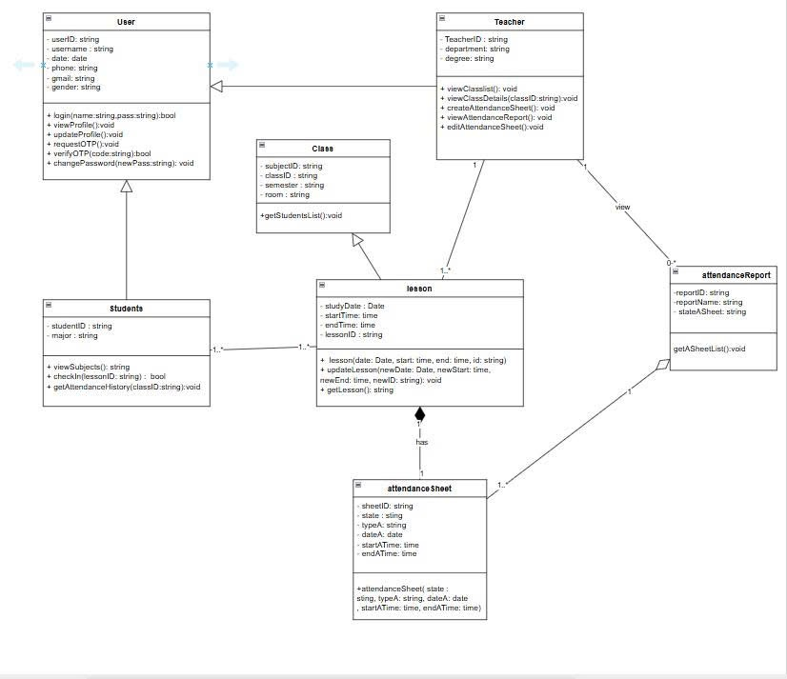

VII.Data Diagram
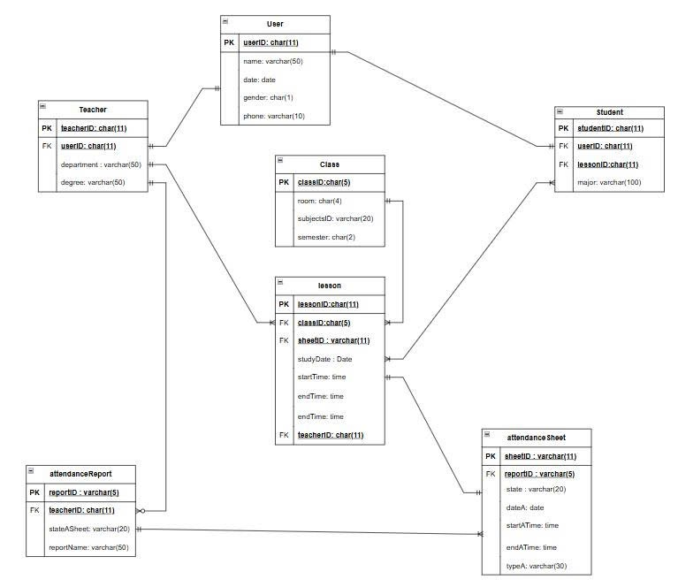
VIII.Interface Decription

1. System Overview
The system is developed as a web-based application with a modern interface, using a flat design style that helps users easily observe and interact with the system. The entire interface is divided into two main areas: the user authentication area (login and forgot password) and the main working area (Dashboard) after successful login.

2. Detailed Description of Screens

2.1. Login Screen
The login screen is designed in a card layout and centered on the screen to help users focus.
Main components include:
- Title: Displays the text “Login” at the top.
- Input Form:
  - Username input field with a user icon.
  - Password input field with a lock icon and masked characters for security.
- “Forgot Password?” link: Located below the password field.
- “Login” button: Large in size and spans the full width of the form.
- Sample account information: Displayed at the bottom for testing purposes (Lecturer/Student).
- Error notification: When incorrect login information is entered, the system displays an error message with a warning icon.
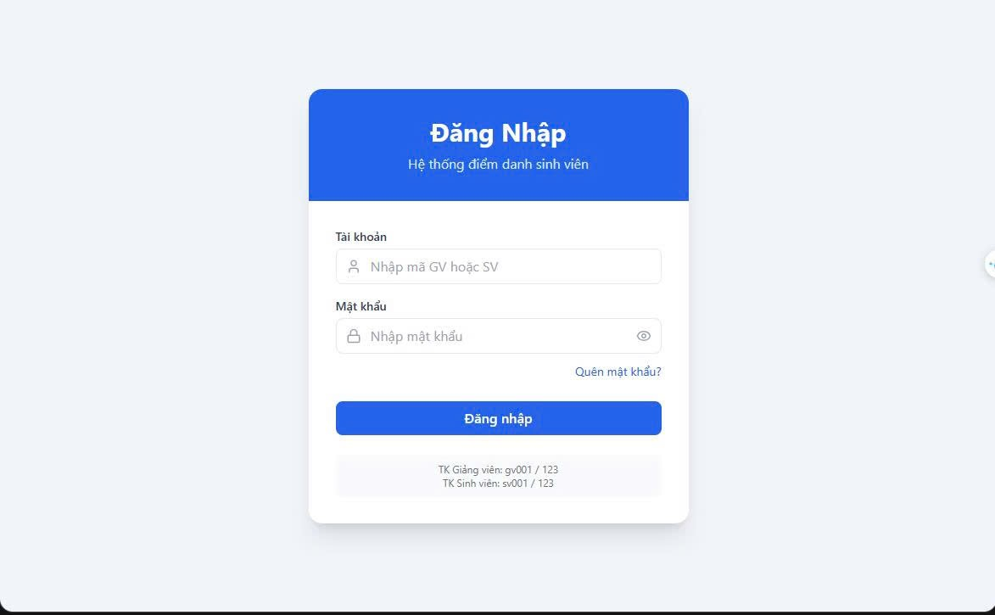

2.2. Forgot Password Screen
The forgot password screen has a layout similar to the login screen and is designed as a step-by-step process for better usability.
The process consists of three steps:
- Enter phone number: The user enters their phone number and clicks the “Get OTP” button.
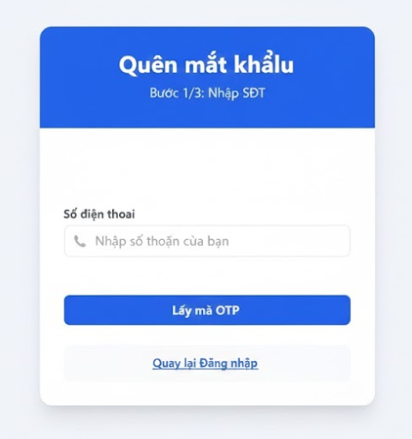
- OTP verification:
  - The system notifies that the OTP has been sent to the entered phone number.
  - The user enters a 6-digit OTP code and clicks the “Verify” button.
  - A “Resend OTP” option is available if the code is not received.
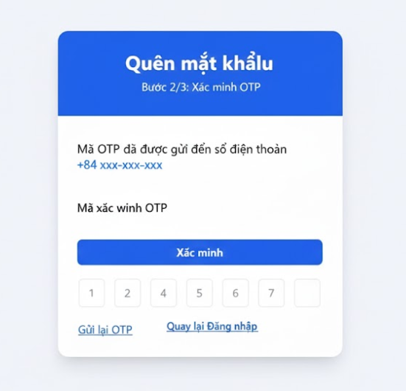
- Reset password:
  - The user enters a new password and confirms it.
  - Clicks the “Reset Password” button to complete the process.
Additionally, a “Back to Login” button is provided at the bottom of the form.
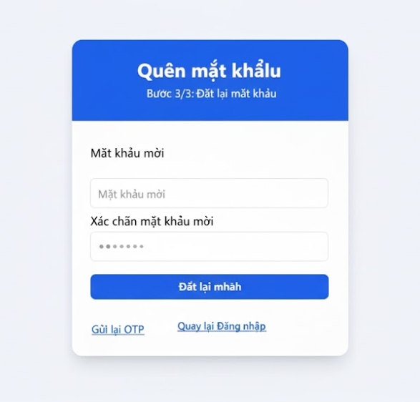

2.3. Main Screen (Dashboard)
After successful login, the main interface is divided into two sections:

a. Sidebar
The sidebar is located on the left side of the screen and includes:
- User information: A circular avatar displaying the first letter of the user’s name, along with the full name and role (Lecturer or Student).
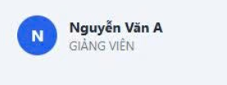
- Navigation menu:
  - Teaching Classes / Courses (book icon).
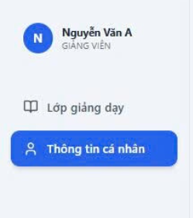

Personal Information (user icon).

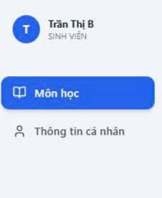
- Logout button: Located at the bottom of the sidebar with a logout icon.
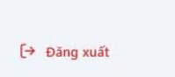

b. Main Content Area
Located on the right side of the screen, this area displays content that changes based on the selected menu option.

2.4. Class List Screen
This screen displays a list of classes or registered courses depending on the user’s role:
- For lecturers: “Teaching Class List”.
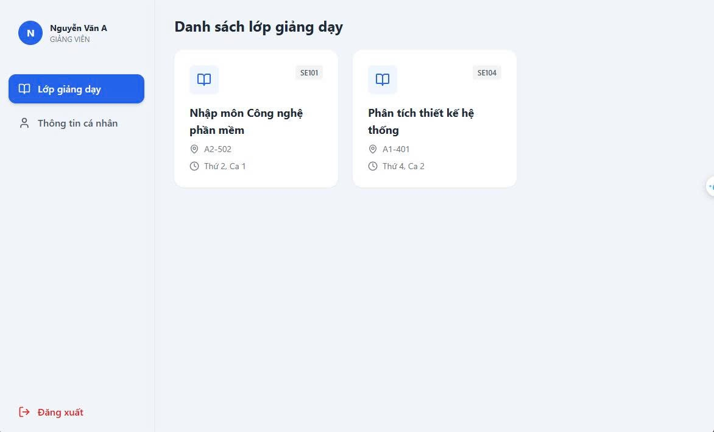
- For students: “Registered Courses”.
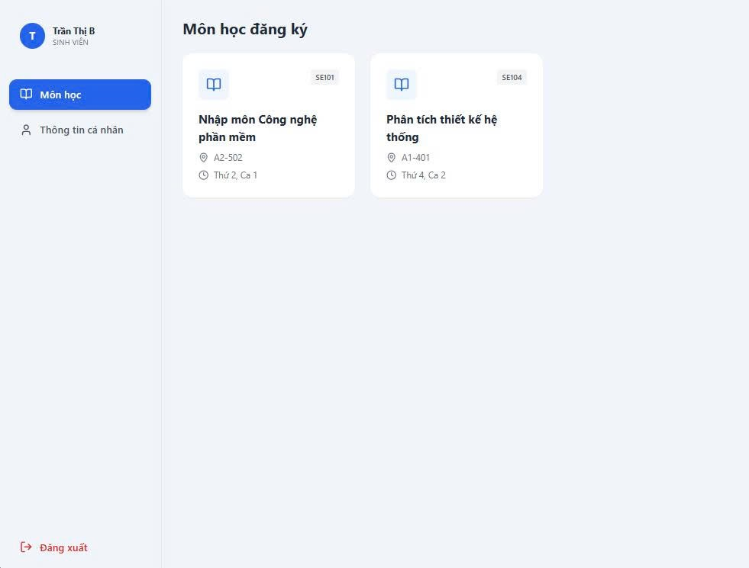
Classes are displayed in a grid layout with multiple cards.
Each class card includes:
- Book icon.
- Class code (e.g., SE101).
- Course name displayed prominently.
- Classroom and schedule information.
When hovering over a card, it slightly elevates to create a visual effect. Users can click on a card to view class details.

2.5. Class Detail and Attendance Screen
This screen shows detailed information for a specific class.
- Back button: Allows users to return to the class list.
- Class information banner: Displays course name, class code, semester, classroom, and lecturer.
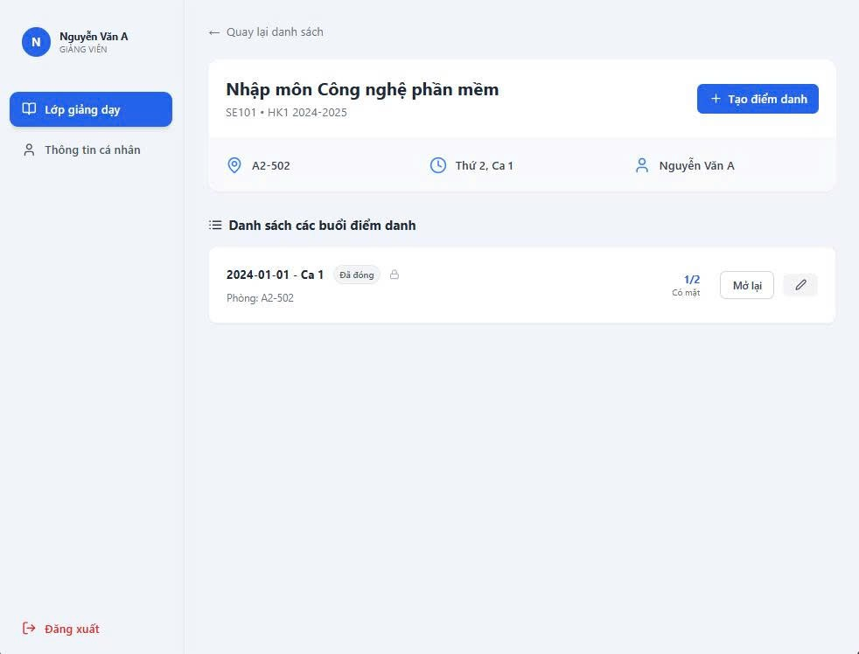
- Lecturer functions: A “Create Attendance” button for creating a new attendance session.
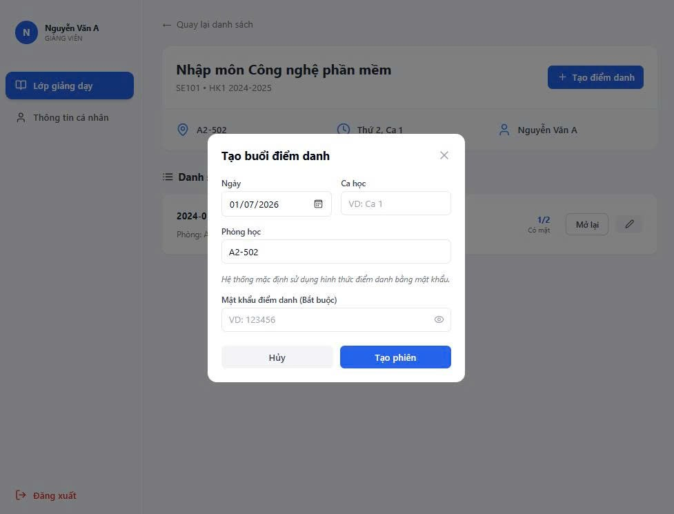

Attendance Session List
Attendance sessions are displayed in a list format:
- The left side shows the date, class period, and status (open or closed).
- The right side displays corresponding actions.
For lecturers:
- View a quick summary of student attendance.
- Open, close, or edit attendance sessions.
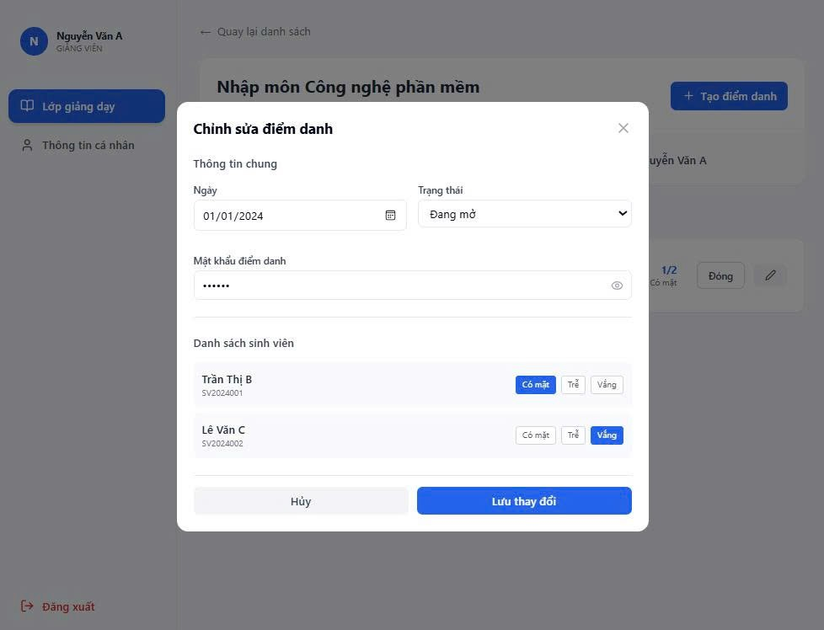
For students:
- If the session is open:
  - enter a password if want to attendance
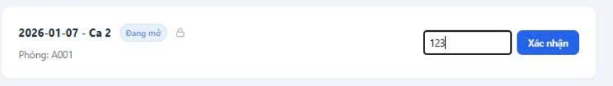
- If the session is closed: The system displays the attendance result.

Create and Edit Attendance Session
Lecturers can create or edit attendance sessions via a popup window.
In addition, lecturers can manually adjust attendance status (present, late, absent) for each student in the class list table.

2.6. Profile Screen
This screen displays the user’s personal information.
- Non-editable information: Full name, ID number, date of birth, gender, faculty/class.
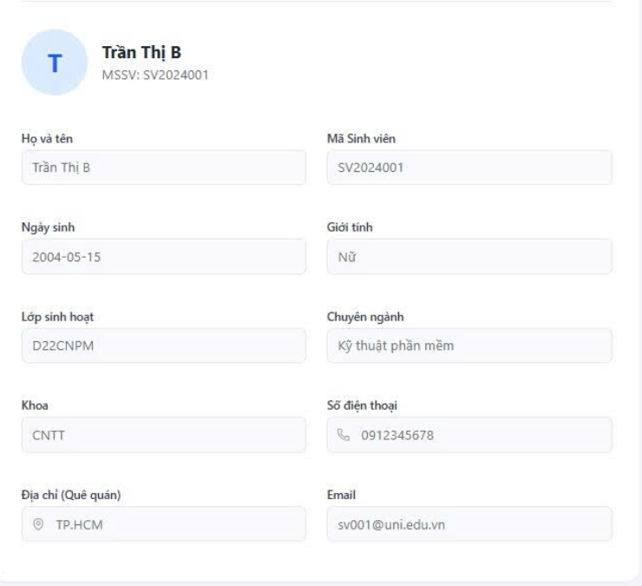

3. Notification System
The system provides quick notifications displayed at the top-right corner of the screen. Notifications slide in, remain visible for a few seconds, and then automatically disappear.
Types of notifications include:
- Success notifications: For example, “Attendance recorded successfully”.
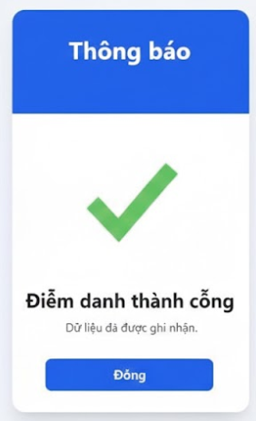
- Error notifications: For example, “Incorrect password” or “Connection error”.
